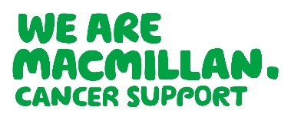
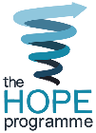

The HOPE Programme- Resources

The HOPE programme – Help to Overcome Problems Effectively – is a health and lifestyle
coaching course to support people after cancer treatment. Originally developed by Coventry
University, it is now a licensed and accredited self management programme run in partnership with Macmillan Cancer Support.

There are a range of HOPE resources available to order or download from Be.Macmillan. Including promotional leaflets, posters and course materials. (These should only be used by Macmillan Trained HOPE Facilitator)

For details of how to train as a HOPE facilitator yourself, please contact the Learning and
Development team in your area:

North Northlearning@macmillan.org.uk
North West Northlearning@macmillan.org.uk
Midlands SWMidslearning@macmillan.org.uk
South and East LondonSElearning@macmillan.org.uk
London LondonSElearning@macmillan.org.uk
South West SWMidslearning@macmillan.org.uk

