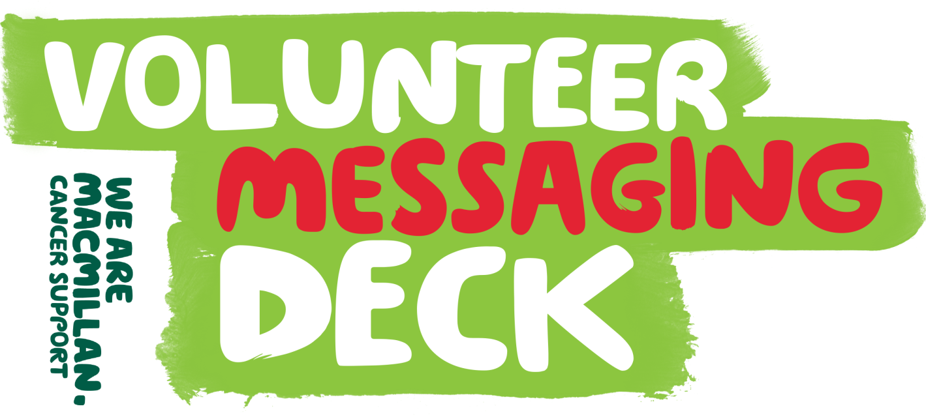

This guide has been created to help you write consistent and compelling communications to and about volunteers, in line with our volunteer proposition.
It has been structured into sections of similar content to help you find the right messages quickly. It is also intended to be flexible, so you can pick and choose or mix and match the paragraphs, sentences or phrases that best suit the communication you are creating.

Sections in this document:
- What to say when recruiting volunteers

- Thanking volunteers

- Some ways to bring out the urgency of our cause

- Showing existing volunteers what else they could do

- Wrapping up communications – the ‘call to action’

More guidance on communicating with volunteers
There is also a more comprehensive toolkit on communicating with volunteers and a series of artwork templates available from The Library (you will be prompted to create a login to The Library if you do not already have one). If you have any queries when using any of these tools, please contact volunteermarketing@macmillan.org.uk

What to say when recruiting volunteers
Whether you can spare minutes or months, hours or days, the time you give by volunteering with Macmillan really will matter.
You might choose to lend an ear in our information centres, fundraise at our events, or do a few odd jobs for people in their home. However you volunteer, you’ll be doing something amazing for people at a difficult time so they can start to feel more in control.
Make time matter. Volunteer today at macmillan.org.uk/volunteer

Bringing in the Macmillan proposition:
Could you make someone’s day by doing a few odd jobs? Or join us to make some noise cheering at our events? How about making a difference by interning at our offices? Sounds good? Then volunteer with Macmillan today.
Because whether it’s minutes or months, hours or days, whatever time you can give really will matter. You’ll be gaining new skills and building on what you’re already great at. And you’ll be helping us to support people when they need it most, so they can start to feel more in control.
Discover all the ways to get involved with Macmillan today at macmillan.org.uk/volunteer

Another way altogether:
Rewarding, friendly, invaluable, awesome. Just four of the ways people have summed up volunteering with Macmillan. But to put it into words how much our volunteers mean to the people affected by cancer is a little trickier.
It’s the smile on someone’s face when you’ve done a few odd jobs for them. It’s the reassuring chat in our information centre. It’s the power your signature on our campaign has. It’s all you do to help us make sure no one faces cancer alone.
Because whether you’ve got five minutes, a few hours a week, or a couple of days each month, the time you can give Macmillan really will matter. You’ll be helping us support people at a difficult time, so they can start to feel more in control.
Find out more today at macmillan.org.uk/volunteer

Thanking volunteers
By volunteering with Macmillan you’ve done something amazing for the 2.5 million people living with cancer. Thank you.
Because whether it’s five minutes or five days, the time you give by volunteering really does matter – helping us make sure no one faces cancer alone.
Volunteers are at the heart of Macmillan. Discover all the ways to get involved at macmillan.org.uk/volunteer

Linking with the Not Alone campaign:
Every minute you give matters

Thank you. Without the amazing effort of volunteers like you, we wouldn’t be able to support millions of people affected by cancer.

Because whether it’s minutes or months, hours or days, the time you give by volunteering for Macmillan really does matter - helping us make sure no one faces cancer alone.
There are so many ways you can volunteer. Discover more at macmillan.org.uk/volunteer

And another way to say ‘thank you’:

Every minute you give matters

Thank you. Whether it’s minutes or months, hours or days, the time you give by volunteering for Macmillan really does matter.
You might have lent an ear to someone in an information centre, fundraised at our events, or offered a helping hand to someone in their home. However you’re involved, you’re helping us be there for people at a difficult time so they can start to feel more in control.
Discover more about volunteering with us at macmillan.org.uk/volunteer

Some ways to bring out the urgency of our cause
Option one:
There are 2.5 million people living with cancer right now. And the sad truth is, this number is only going to go up. That’s why we need people like you to volunteer your time in whatever way you can today.
You might want to fundraise at an event, support someone by doing a few odd jobs, volunteer in our offices, or sign a campaign. It could be that you’ve got five minutes to spare, a few hours to lend a hand, or a few days a week to give.
However you want to get involved, it really will matter – helping us make sure no one faces cancer.
Do something amazing today at macmillan.org.uk/volunteer

Option two:
More. We all want it. But when it comes to volunteering for Macmillan we desperately need it. Because with 2.5 million people now living with cancer, our challenge to make sure no one faces cancer alone has never been bigger.
Discover how else you can get involved at macmillan.org.uk/volunteer

Showing existing volunteers what else they could do
Option one:
Volunteers like you mean millions of people affected by cancer can get support. And without you, we couldn’t do what we do. That’s why we need you to make an even bigger difference by <insert your own call> today.
Find out more at macmillan.org.uk/volunteer

Option two:
There are many ways volunteering with Macmillan can really make a difference for people affected by cancer. And the choice is yours how you get involved.
Make your time matter. Volunteer with Macmillan today at macmillan.org.uk/volunteer

Wrapping up communication – the ‘call to action’
Wherever possible, we use a clear ‘call to action’ to encourage the reader to get more involved. Our preferred way to do this is with the phrase...

‘Make time matter. Volunteer today.’

Other options for recruiting volunteers include:
- ‘Get involved in a way that fits you at macmillan.org.uk/volunteer’
- ‘Discover more about volunteering with Macmillan at macmillan.org.uk/volunteer’
- ‘Do something amazing today at macmillan.org.uk/volunteer’
- ‘Discover all the ways to volunteer with Macmillan today at macmillan.org.uk/volunteer’
- Or simply ‘Get involved today at macmillan.org.uk/volunteer’
Each of the above phrases can be preceded by the sentence ‘Make time matter.’, depending upon how strong you want your call to action to be.

Calls to action for existing volunteers
For warmer audiences, we sometimes soften the call to action. Our preferred way to do this is as follows...

‘Volunteers are at the heart of Macmillan. Discover all the ways to get involved at macmillan.org.uk/volunteer’

Other options to wrap up with existing volunteers include...
- ‘We couldn’t do it without you. Discover more at macmillan.org.uk/volunteer’
- ‘Please continue to make an amazing difference. Find out more about all the ways to give your time at macmillan.org.uk/volunteer’
- ‘There are so many ways you can volunteer. Discover more at macmillan.org.uk/volunteer’
- Or simply ‘Discover how else you can get involved at macmillan.org.uk/volunteer’
There is more guidance on how to present your call to action visually in the Volunteer Toolkit on The Library.

